**Project Title: Kidney Tumor Segmentation Challenge**

# Team

Mohamed Ahmed <>

Rohit Saluja <rsaluja@kth.se>

**Introduction**

The challenge that our team picked for the project was first announced on March 15, 2019 and was held in conjunction with MICCAI 2019 in Shenzhen, China [1]. The motivation and the objective of the challenge is as follows.

Each year there are more than 400,000 thousand cases of kidney cancer and the most common way of treating them is by doing a surgery [2]. There is a lot of interest in finding out how a tumor morphology [3] is related to the surgical outcome and also in developing advanced surgical planning techniques [4]. Due to these reasons, exploring automatic semantic segmentation of a kidney tumor becomes an interesting challenge that can have a very fruitful impact.

**The data**

The challenge dataset contains arterial phase abdominal CT scans of 300 unique kidney patients along with their semantic segmentations. 210 of these were used for model training and validation, 90 were held out by the challenge organizers for testing. **Mention size of the images.**

**Solution Pipeline**

**Data Loader**

Making the data loader for training, validation, testing

Reading the data on the fly

**Data Preprocessing**

Changing the data to normal structure (/Image, /Mask)

Fixing the inconsistency in the sizes of the images

**Data Postprocessing**

Making the predictions and saving the results

Output visualization and metrics reporting

**Training**

Applying different training techniques ( e.g. normal training, k-fold, weight maps, auto context

**Experimentation**

**Tools Used**

* Numpy, Nibabel, OS, Skimage, SimpleITK
* Implemented two pipelines, one with TensorFlow (keras) and one using Pytorch.
* In the pipeline with TensorFlow, we have experimented with multiple configurations.
* The pipeline built with Pytorch is basic vanilla pipeline. The motivation behind using both TensorFlow and Pytorch was to get a hands-on experience of building end to end pipelines with both the libraries. This aligns with the motivation of the course.

**Models and Configurations**

**Competition Metric**

We have used two metrics to evaluate the performance of our model, Dice Coefficient (Normal) and custom Dice Coefficient which was provided by the competition organizers.

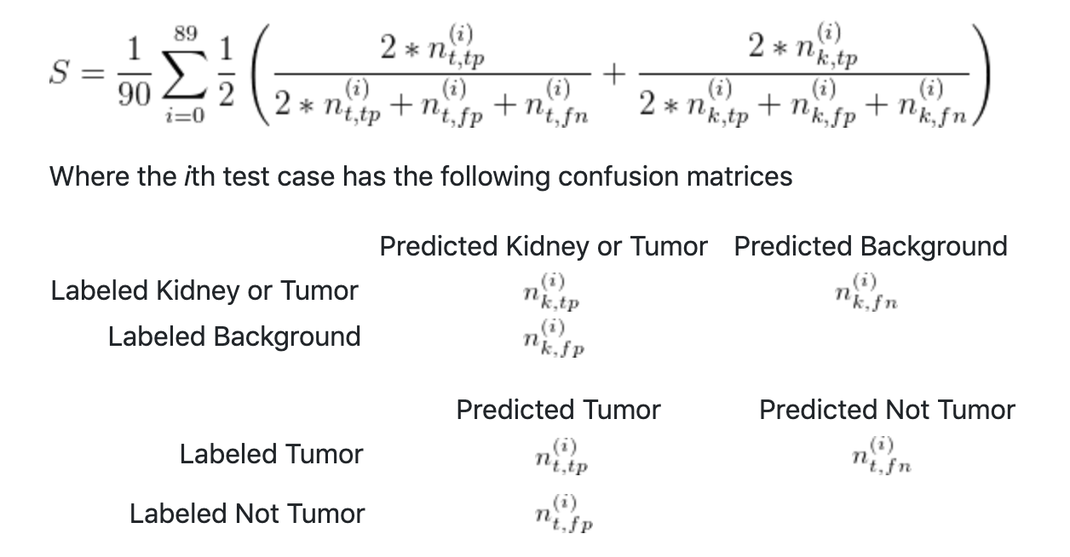

Figure 1: The confusion metrics used in the competition

**Challenges Faced**

**Results**

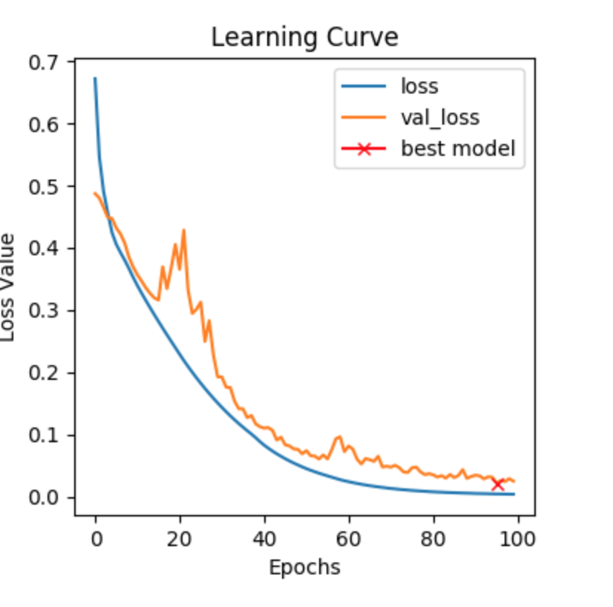 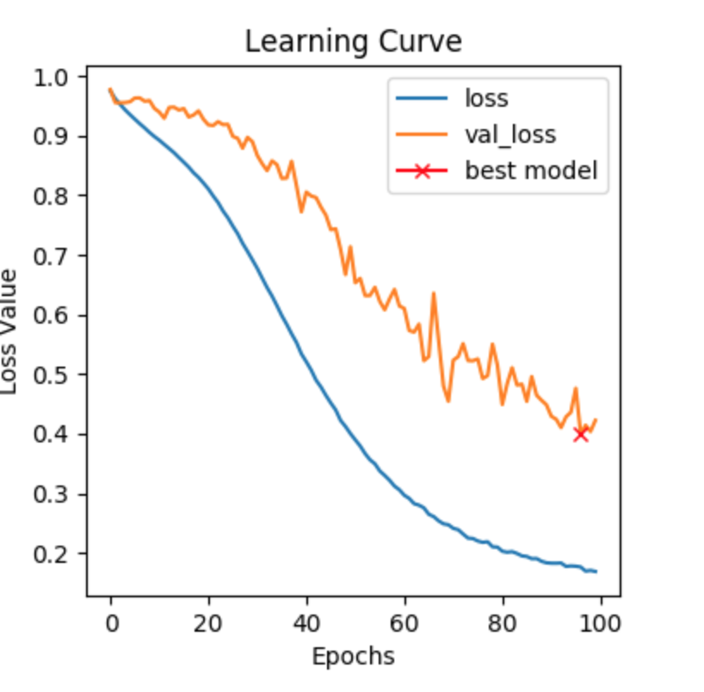

Figure 2: Dice Loss (Normal) Figure 3: Using Dice Loss from

the competition (100 epochs)

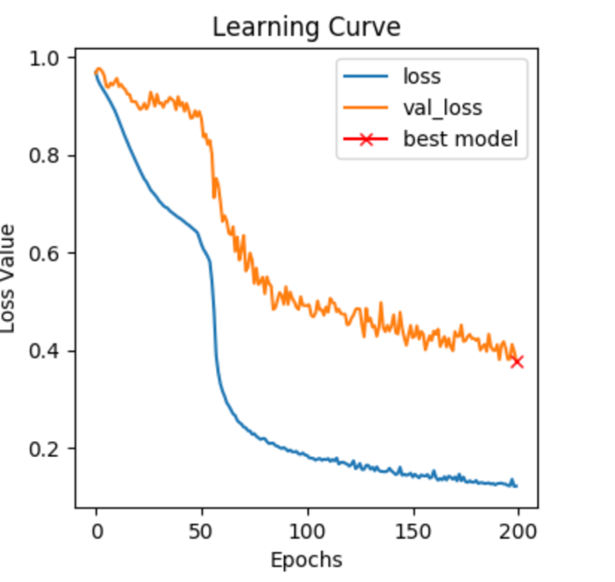 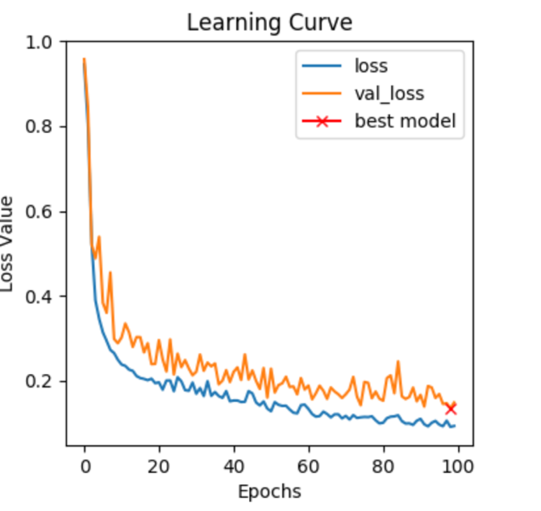

Figure 3: Using Dice Loss from Figure 4: Using Dice Loss from

the competition (200 epochs) the competition (100 epochs),

increasing learning rate to .0001

from .00001

Initially, the metric we used for performance evaluation was the normal dice loss over 100 epochs in order to get a benchmark and the model performed very well. Then we moved on to evaluate the model performance using the dice coefficient from the competition over 100 epochs, but the results were not as good as the normal dice loss.

We tried fixing this by doubling the number of epochs and increasing it to 200. The validation loss started saturating at around 0.4 which was still not good enough. In order to improve the performance, we increased the learning rate from .00001 to .0001 and evaluated the performance with the dice loss from the competition over 100 epochs. We were finally able to obtain good results with the dice loss from the competition.

**Results on the Testing data**

|  |  |  |
| --- | --- | --- |
| Mean Kidney Tumor Dice Loss | Kidney Dice Loss | Tumor Dice Loss |
| 0.5229 | 0.8438 | 0.2020 |

References:

1. https://kits19.grand-challenge.org/home/
2. Kidney Cancer Statistics.” World Cancer Research Fund, 12 Sept. 2018, www.wcrf.org/dietandcancer/cancer-trends/kidney-cancer-statistics
3. Kutikov, Alexander, and Robert G. Uzzo. "The RENAL nephrometry score: a comprehensive standardized system for quantitating renal tumor size, location and depth." The Journal of urology 182.3 (2009): 844-853.
4. Taha, Ahmed, et al. "Kid-Net: Convolution Networks for Kidney Vessels Segmentation from CT-Volumes." arXiv preprint arXiv:1806.06769 (2018).